PS-2120

IT24101461

LABSHEET – 07

EXERCISE

Q1

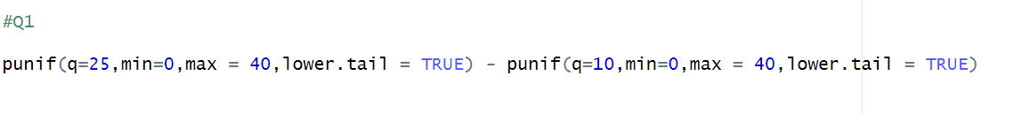



Q2

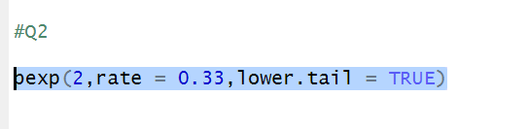



Q3 – part 1 , part 2

